CURRICULUM VITAE
OF
DR. RAQIBA Yasmin
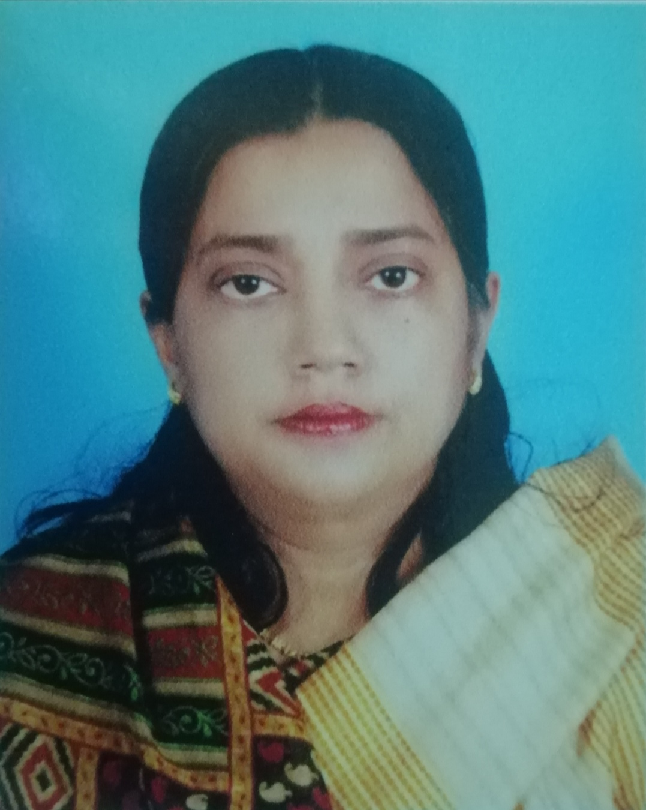
- Name | : | Dr. Raqiba Yasmin
- Father’s Name | : | Emeritus Professor Dr. A K M Yaqub Ali
- Mother’s Name | : | Rahima Yaqub (Dead)
- Husband's Name | :  : | Dr. Ruhul K M Saleh
- Date and place of birth | : | 10 January 1970, Bangladesh
- Profession | : | Teaching & Research
- Date of joining | : | 18 December 1994 in Islamic University, Kushtia
- Present address | : | Professor
Office | : | Dept. of Public Administration, Islamic University, Kushtia
Home | : | Phone: 071-71709 (Res.)  Mobile: 01712-111470  E-mail:
- Permanent address | : | 'Kantara' 22/2, Khodadad Khan Road, Thanapara, Kushtia
- Nationality | : | Bangladeshi (By birth)

- Educational Background

Year of Pass: | Name of Exam | Board/  University | Name of  Institutions | Results
1984 | S.S.C (Arts) | Rajshahi Education Board, Rajshahi | Rajshahi University School & College | First Division  (6th place)
1986 | H.S.C (Arts) | Do | Rajshahi College, Rajshahi | First Division  (3rd place)
1989 | B.S.S | Rajshahi University | Dept. of  Political Science | Upper Second Class  (1st Position)
1990 | M.S.S | Rajshahi University | Do | 1st Class (1st Place)
2002 | Ph.D | Islamic University, Kushtia | Islamic University, Kushtia | Awarded

- Title of Ph.D Thesis | : | "The Role of Parliamentary Committee System in Parliamentary Democracy of Bangladesh (1972-96): A review"
- Specialization | : | Govt. and Politics, Parliamentary Committee System, Political Sociology, Bangladesh Public Administration, Problems of Govt.
- Language Proficiency | : | - Bengali (Mother Tongue)  - English (Read, Write and Speak)
- Extra-curricular Activities
  - House Tutor (Begum Khaleda Zia Hall).
  - Part-time teacher of Islamic History and Culture, Islamic University, Kushtia from 1995-1996 and 2002-2005.
  - Editor, the Journal of Politics and Administration, the Dept. of Public Administration.
  - Lecturer, the Dept. of Political Science, Rajshahi University.
  - Founder Chairman, the Dept. of Political Science, Islamic University, Kushtia from 2016-2019.
- Published Books and Research Papers
  - The Parliamentary Democracy and the Parliamentary Committee System in Bangladesh 1972-1996 (Bangladesh Samsadiya Ganatranta O Samsadiya Committee Babastha 1972-1996), Mawla Brothers, Banglabazar, Dhaka, 2007.
  - Distinguished Personalities (Smraniya Baranaya Baktittya), Chapter-Titumir, Bangladesh Book Corporation, 2015.
  - The Political and Constitutional Development of Bangladesh (1757-1972), Novel Publishing House, 2/3 Paridas Road, Banglabazar, Dhaka, 2014.
  - Raqiba Yasmin, Rajnititye Samarik Hastakheep : Prekkit Bangladesh, Samajik Biggan Journal, 5th Volume, 1998, Rajshahi University.
  - Raqiba Yasmin and A. K. M. Motinur Rahman,” Theory of Development planning and the planning process in Bangladesh, Social science Review Vol. 17. No June the Dhaka University studies, part,-D, Faculty of Social Sciences.
  - Raqiba Yasmin, Bangladesh-Bharat Samparka: Parsange Ganga Pani Bandhan Chukti, 1st Part, 2nd Volume, December 1999, Islami University Studies.
  - Raqiba Yasmin, Tattabadhayak Sarker: Bangladesh Paripakkit, Lock Prashashan Shamayaki, 18th Volume, March 2001
  - Raqiba Yasmin, Islame Paribarik Kallan abong Ulamar Bhumika, Islamic Gabeshana Patrika, 2nd Volume, 2001, Center for Islamic Research, Rajshahi, Bangladesh.
  - A.K.M. Motinur Rahman and Dr. Raqiba Yasmin, Bisma Santi O Ajke Jaitsangha: Ekti Parjalachana, 5th Part, 2nd Volume, December, 1997, Islamic Studies.
  - Raqiba Yasmin, Rastrabhasa Andalan O Bengali Jatiyatabad: Ekti Samikkhya, 8th Volume, 1st Part, Islamic University Studies.
  - Raqiba Yasmin, Muslim Reneshay Syed Amir Ali Abadan, 9th Volume, 1st Part (Parkasitabba), Islamic University Studies.
  - Raqiba Yasmin, Antarjatik Rajnititye Morgenthao-Er Ekti Samikkhya, Islamic University Studies, 4th Volume, 1st Part, 1995.
  - Raqiba Yasmin , Gias Uddin & ‘Abudur Rashid,”NGO Intervention and women Empowerment Amongst the Indigenous Santal Community in Rajshahi“ The Bangladesh Journal of Resources and Development (BJRD); N. A. Khan (ed.) 1(1):PP. 154.(e) CERDER. ISSN: 1683-1616 by centre International de‘ISSN, France.
  - Dr. Ruhul Kuddus Md. Saleh O Dr. Raqiba Yasmin, Uttarbanger Nagarayane Takshal Nagari (1200-1776), The Islamic Studies Journal, 10th Volume, 1st Part-E.
  - Dr. Raqiba Yasmin, Bangladesher Rajnititye Pamcham Jatiya Samsad-Er Karjakarita: Ekti Parjalachana, Rajshahi University Law Journal, 2005, Rajshahi University, Rajshahi.
  - Dr. Raqiba Yasmin, Bangladesh Jatiya Committee Babostha: Er Karjakaritya (1973-1975), Lock Parshashan Patrika, 9th Volume, Kartick 1411/November, 2004
  - Dr. Raqiba Yasmin, Mantranalay Samparkita Committeeshamuha: Prashanga Pancham Jatiya Sangsad, Islamic Gabeshana Patrika, 3rd Volume, Center for Islamic Research, Rajshahi.
  - Dr. Ruhul Kuddus Md. Saleh and Dr. Raqiba Yasmin, Muslim Banglar Katipay Mudrar Lipigath: Aytihashik Upadan Anusandhan, Journal of the Institute of Islamic Education & Research 2005.
  - Dr. Raqiba Yasmin & Kafil Uddin Ahmed,” Committee Systems in Bangladesh parliament (1972-2001), Journal of the Institute of Bangladesh Studies, Vol, xxxix, 2006.
  - Dr. Raqiba Yasmin, Pancham Jatiya Sangsad Pathio Katipay Guruttapurna Committee: Ekti Parjalachana, Rajshahi University Law Journal, 2006, Rajshahi University, Rajshahi.
  - Dr. Raqiba Yasmin, Bangladesh Samsadiya Ganatranga O Er Karjakarita (1972-1975), Professor Dr. A K M Yaqub Ali Sambardhana Grantha.
  - Mohammad Johurul Islam & Dr. Raqiba Yasmin , “Protection of Indigenous Knowledge in Bangladesh: An Agenda for Development,” The Islamic University Studies, Faculty of Law & Sharia , Vol,4,No 2, 2003-2004, Islamic University, Kushtia.
  - Dr. Raqiba Yasmin, ‘‘Strengthening the local Government and effective Role of Upazila Perished in Bangladesh” https: I eardrum. Org/Journal/ i=JPASWR. Refereed Journal. Sep 2,2017.
  - Dr. Raqiba Yasmin, Embdadul Haque and Sania Sultana, Monga and Its Impact on the Northern Region of Bangladesh, Journal of Political and Administration, Vol.4,Nos.1y 2, 2013, ISSIV 1818-9571, Dept. of Politics and public Administration Islamic University, Kushtia, Bangladesh.
  - Dr. Raqiba Yasmin and Tanjiul Islam, "The Functions of Prime Minister: Bangladesh Perspective", Volume-18, No-1, 2018, Islamic University Studies.
- Details of Research Guidance M.Phil
  - Sherina Khatun, Fellow, Dept. of Public Administration, Assistant Professor (at Present), the Dept. of Political Science, Islamic University, Kushtia.
  - Rabiul Islam, Fellow, Dept. of Public Administration, Islamic University, Kushtia.
  - Parvin Aktar, Fellow, Dept. of Public Administration, Islamic University, Kushtia.
- Seminar and Symposia Attend
- Attended and Presented a paper in the Seminar 'Understanding Bangladesh 2019;, Organized by the Dept. of Begum Rokeya University, Rangpur.
- Attended and Presented a paper titled 'Good Governance in Parliamentary Democracy of Bangladesh: Role of Parliamentary Committees with reference to 8th and 9th Jatiya Sangsad in the 1st International Conference on 'Governance in the 21st Century in South Asia: Challenges and Ways Forward', Organized by the Dept. of Government and Politics, Jahangirnagar University, Savar, Dhaka, Bangladesh.
- Delivered a Lecture titled 'Leadership Styles: Bangladesh Perspective', Organized by the Dept. of Political Science, North Bengal International University, Rajshahi, December, 2019.
- Attended and Presented a paper titled "Bangladesh Sambidhaner Samsadhanisamuha: Ekti Parjalochana" in Paschimbanga Itihas Sangsad Sammellam.
Signature-
Dr. Raqiba Yasmin

